**AI**

**Project Report**

**Corona Ranger**

**-The ChatBot**

**Section:** K18TS

**Group Members :**

Parth Chauhan (42) 11801772

Saniya Chandanan (46) 11805683

**Abstract :**

Corona-Ranger, the chat bot is based on Natural Language Processing branch of Artificial intelligence. It is useful for the condition that we all are facing in this pandemic.

The project is made using Python language in which certain libraries like Nltk (Natural Language processing toolkit), Numpy, Pandas, Strings, Wikipedia.

It is takes an input from the user in the form of keywords and it matches those keywords in its data-set to give out the corresponding output saved in it.

**Introduction :**

The project on the Artificial intelligence has been presented with a chat bot named as Corona Ranger which helps the community or the user in the way of an interaction that we deal with others. The bot helps us to go head on with the epidemic that we have been facing now a day which has caught all of us with nothing to defend with and we can easily get our answers just by siting at the table and nothing to worry about.

It gives all the possible answers related to corona disease. Since, in this lockdown, we cannot go outside and cannot meet people, it is an interactive way to get to know about how world is dealing with it.

The bot introduces a two more interactive phases. Like web search, where user can search any other additional information other than covid-19. The second feature is self-diagnose. In this lockdown, if any one falls ill and is confused whether he/she should go to hospital or not, because going to hospital can also increases the chance to get affected. So here we provide the user to self-diagnose them and it will also check their travel history.

**Objectives :**

The objective we achieved here are the basics of Natural language processing. Tokenization, lemmatization and breaking of sentence into its elements such as nouns, pronouns and adjectives and based on that the keywords of the sentence are thus used to find the results in the data set as well as the web for the results which are not found in the data set.

The objective here was to achieve an interface to the user where he could find himself the answers in a reasonable way and resolve his issues with the epidemic that we are facing.

The main objective here was to provide all the related information regarding the pandemic corona. Information like news, whether national or international, information regarding health, information regarding education, information regarding economy , everything will be provided to user in one place. They need not to search different places for different news and it provides the exact figures.

**Methodology :**

The main methodology that is used here is Python language and its basics. The Python language is used to build the bot and also the libraries that we are using here are Numpy, Panda and etc.

The second methodology that has been used in the program are the basics that we learn such as basics of Natural language processing like Tokenization, Lemmatization as to make it, and to take input to store the data. Then use the data after tokenization for making a dictionary and searching a correct output for user from the data set.

A data set was created keeping a normal human being in the mind, questions that can be asked as per user and a correct answer was thus fed to the system and as in to show an output also we used a certain feature that helps us to use the web for expected result where user can search for whatever he wants and some lines of summary available would be told to the user.

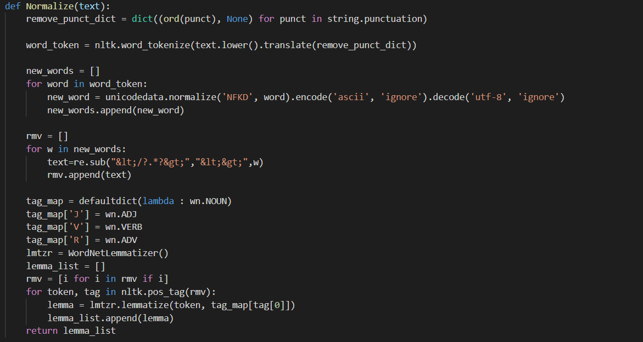

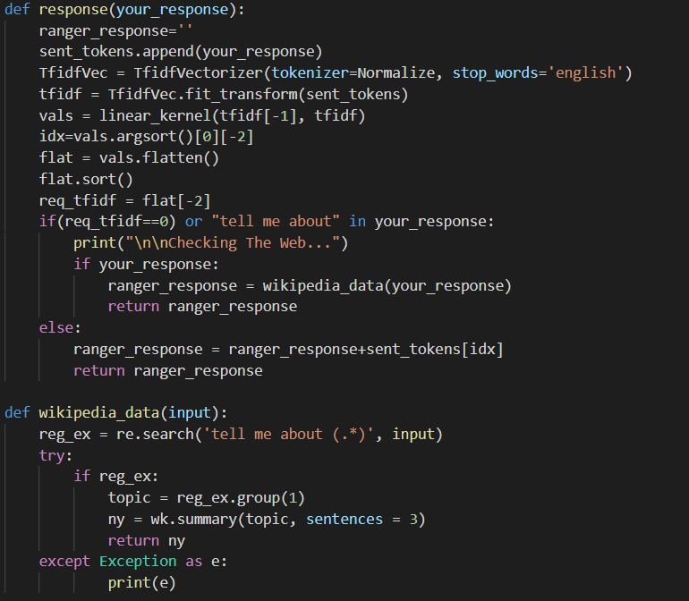

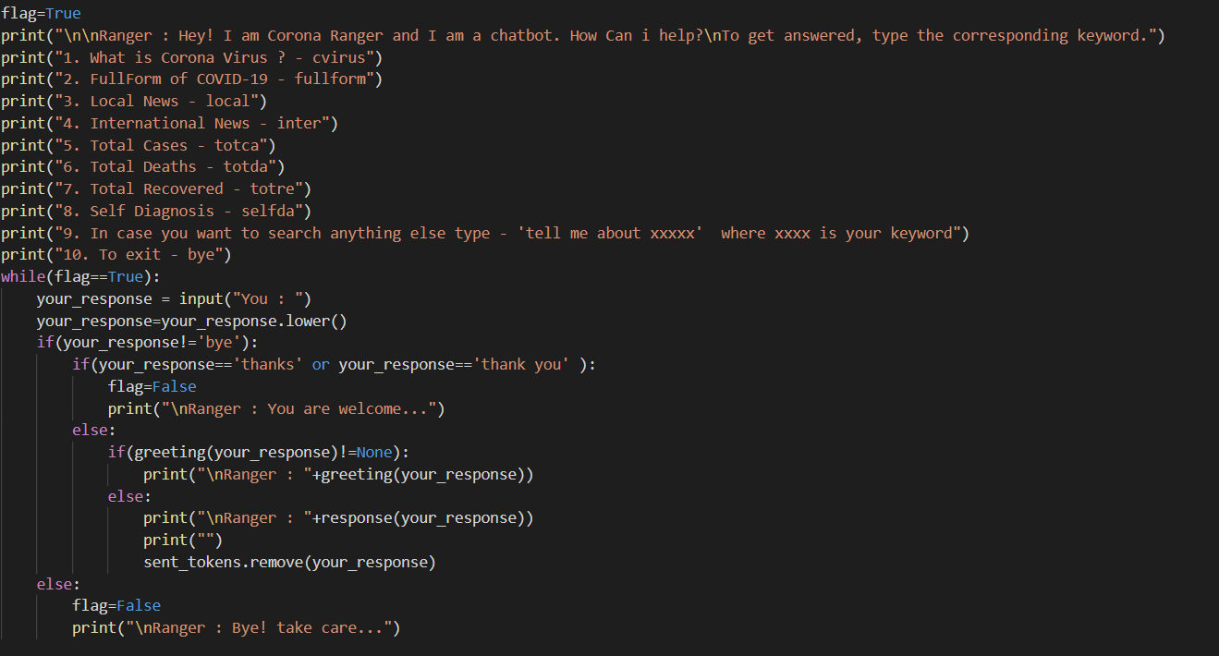

**Results :**

With the help of basic learning and projection of what we learnt in the class and adding a pinch from ourselves, we were able to achieve a platform where we have built the chat bot which can even help the user to know if he has to consult a doctor after an interaction with the bot. The bot not only is limited to a certain data set but is also able to give results from the web and give a desired output.

The outputs not only satisfy the users demand as well as works in answering the user regarding basic things that he wants to gather information about without relying of anything/ anyone. It becomes like a hub where he could simply ask whatever he want and thus can grow by simply commuting with the bot and getting himself answered to the various aspects.

The project not only helped us to grow and take a peek outside the box of what we can achieve over the coming decades and set goals and milestones to.

**Conclusion :**

The conclusion of the basic bot that we were able to design was that we were also able to learn from the project assigned to us and we were also able to take a deep dive into the field of Natural language processing. We hope that this bot doesn’t only restrict itself to the part where his dictionary or the data set is limited but we want it to expand and help the people as well.

The learning in the field of Natural language processing not only restricts us to making chat bots but we can even collect data further an analyse how the user wants us to answer his/ her queries as well as we can make a growth in knowledge where we can be helped by knowing what the desirable outcomes might look favourable to acceptance of people.

The Chat bots not only are a good way to produce a reach out to people but also we can even gather information and help in expanding knowledge to understand that user in an innovative manner never seen before.

We can not only pursue this standard but the field is really wide and a large amount of innovations can be made such as replying to a query with an interactive representation as well as a GUI which enhances the understanding of the user.

**Future scope :**

There is a lot of scope in the field as we think that the bots are our future as they are more better in helping humans than humans themselves and they could perform tasks to an utter perfection where even human mind can not reach. Thus, exploring the field might even lead us to build a perfectly capable bot which can train itself with the period of time and doesn’t depend on data set for the answers it has to deliver.

The scope of such chat bots/ interactive interfaces is huge a we can not only learn about human tendencies as well as learn in what behavioral manner a human might need a certain answer. We can not only understand but also train these bots or such projects which can help us understand the character as well as patterns in humans which they exhibit sub-consciously as well as consciously.

Thus, the needy ones could be helped and be better taken care of instead of utilizing a man power and thus such intentions might result in a good aspect leading us in future.